Министерство образования и молодежной политики Свердловской области



ГАПОУ СО «Екатеринбургский колледж транспортного строительства»

Отчёт по программе «**Практическая 15**»

Выполнил: Молотова Виктория Анатольевна

Группа: ПР-21

Преподаватель: Мирошниченко Г.В

2022

**Задание:**

**Входные и выходные данные**

*Входные данные:* truebutton, falsebutton

*Выходные данные:* string “Incorrect” и “Correct”

**Блок схема**

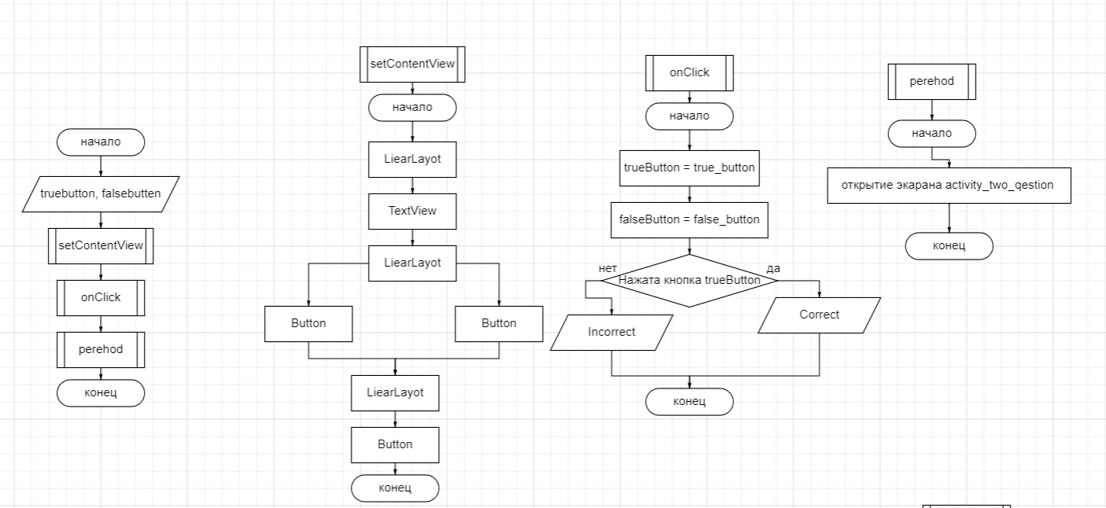

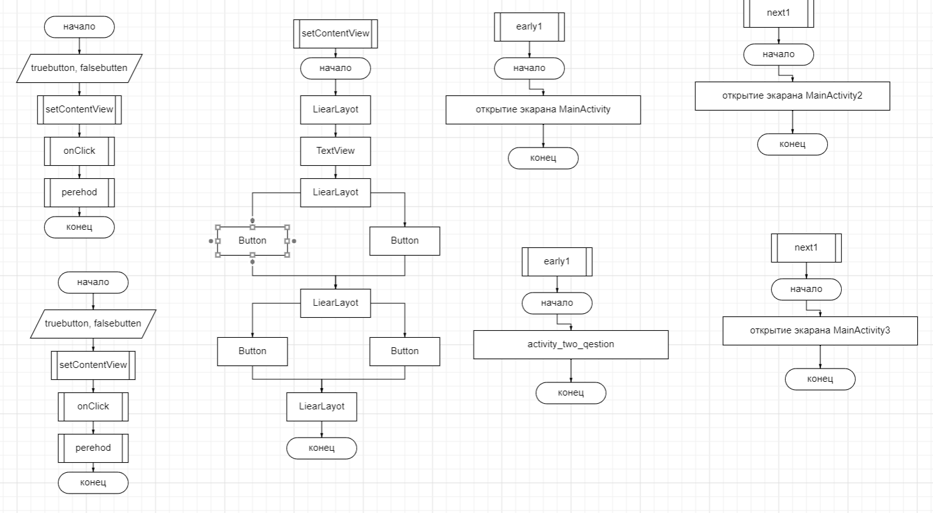

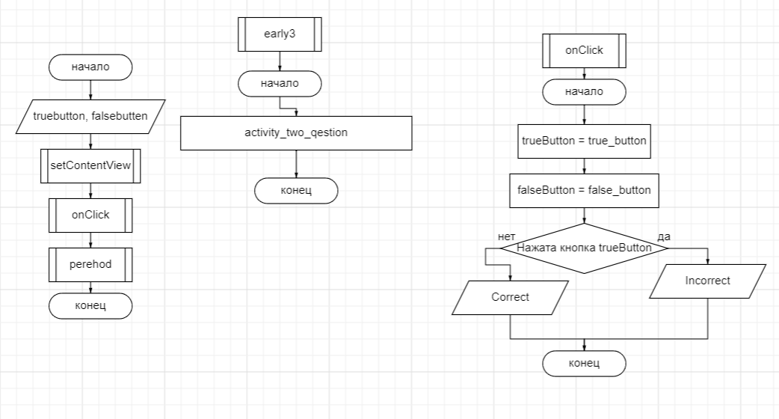

**Листинг программы (если есть)**

<?xml version="1.0" encoding="utf-8"?>  
<LinearLayout xmlns:android="http://schemas.android.com/apk/res/android"  
 xmlns:app="http://schemas.android.com/apk/res-auto"  
 xmlns:tools="http://schemas.android.com/tools"  
 android:layout_width="match_parent"  
 android:layout_height="match_parent"  
 tools:context=".MainActivity"  
 android:orientation="vertical"  
 android:gravity="center"  
 android:background="@color/purple_200">  
  
  
 <TextView  
 android:layout_width="wrap_content"  
 android:layout_height="wrap_content"  
 android:padding="24dp"  
 android:text="@string/qestion_text"  
 />  
  
 <LinearLayout  
 android:layout_width="wrap_content"  
 android:layout_height="wrap_content"  
 android:orientation="horizontal"  
 >  
 <Button  
 android:id="@+id/true_button"  
 android:layout_width="wrap_content"  
 android:layout_height="wrap_content"  
 android:text="@string/true_button"  
 android:textColor="@color/white"  
 android:layout_marginRight="10dp"  
  
 android:background="@drawable/bt1"></Button>  
  
 <Button  
 android:id="@+id/false_button"  
 android:layout_width="wrap_content"  
 android:layout_height="wrap_content"  
 android:textColor="@color/white"  
 android:background="@drawable/bt1"  
 android:text="@string/false_false"></Button>  
 </LinearLayout>  
<LinearLayout  
 android:layout_width="wrap_content"  
 android:layout_height="wrap_content"  
 android:orientation="horizontal">  
 <Button  
 android:id="@+id/next_button"  
 android:layout_width="wrap_content"  
 android:layout_height="wrap_content"  
 android:text="@string/next"  
 android:textColor="@color/white"  
 android:background="@drawable/bt1"  
 android:onClick="perehod"  
 android:layout_marginTop="10dp"/>  
</LinearLayout>  
  
  
</LinearLayout>

package com.bignerdranch.android.practica14molotova  
  
import android.annotation.SuppressLint  
import android.content.Intent  
import android.support.v7.app.AppCompatActivity  
import android.os.Bundle  
import android.view.Gravity  
import android.view.View  
import android.widget.Button  
import android.widget.Toast  
  
class MainActivity : AppCompatActivity() {  
 private lateinit var trueButton: Button  
 private lateinit var falseButton: Button  
 @SuppressLint("SuspiciousIndentation")  
 override fun onCreate(savedInstanceState: Bundle?) {  
  
  
  
 super.onCreate(savedInstanceState)  
 setContentView(R.layout.*activity_main*)  
 trueButton = findViewById(R.id.*true_button*)  
 falseButton = findViewById(R.id.*false_button*)  
  
 trueButton.setOnClickListener **{** view: View **->** var i = Toast.makeText(this, R.string.*correct_toast*,Toast.*LENGTH_SHORT*)  
 i.setGravity(Gravity.*TOP*, 0, 160)  
 i.show()  
 **}** falseButton.setOnClickListener **{** view: View **->** var i = Toast.makeText(this, "Incorrect", Toast.*LENGTH_SHORT*)  
 i.setGravity(Gravity.*TOP*, 0, 160)  
 i.show()  
 **}** }  
  
 fun perehod(view: View) {  
 val intent = Intent(this, activity_two_qestion::class.*java*)  
 startActivity(intent)  
 }  
  
  
  
}

<?xml version="1.0" encoding="utf-8"?>  
<LinearLayout xmlns:android="http://schemas.android.com/apk/res/android"  
 xmlns:app="http://schemas.android.com/apk/res-auto"  
 xmlns:tools="http://schemas.android.com/tools"  
 android:layout_width="match_parent"  
 android:layout_height="match_parent"  
 tools:context=".MainActivity"  
 android:orientation="vertical"  
 android:gravity="center"  
 android:background="@color/purple_200">  
  
 <TextView  
 android:layout_width="wrap_content"  
 android:layout_height="wrap_content"  
 android:padding="24dp"  
 android:text="@string/qestwo"  
 />  
  
 <LinearLayout  
 android:layout_width="wrap_content"  
 android:layout_height="wrap_content"  
 android:orientation="horizontal"  
 >  
 <Button  
 android:id="@+id/true_button1"  
 android:layout_width="wrap_content"  
 android:layout_height="wrap_content"  
 android:text="@string/true_button"  
 android:textColor="@color/white"  
 android:layout_marginRight="10dp"  
  
 android:background="@drawable/bt1"></Button>  
  
 <Button  
 android:id="@+id/false_button1"  
 android:layout_width="wrap_content"  
 android:layout_height="wrap_content"  
 android:textColor="@color/white"  
 android:background="@drawable/bt1"  
 android:text="@string/false_false"></Button>  
 </LinearLayout>  
  
 <LinearLayout  
 android:layout_width="wrap_content"  
 android:layout_height="wrap_content"  
 android:orientation="horizontal">  
 <Button  
 android:id="@+id/early"  
 android:layout_width="wrap_content"  
 android:layout_height="wrap_content"  
 android:text="@string/early"  
 android:textColor="@color/white"  
 android:background="@drawable/bt1"  
 android:onClick="early1"  
 android:layout_marginRight="10dp"  
 android:layout_marginTop="10dp"/>  
 <Button  
 android:id="@+id/next"  
 android:layout_width="wrap_content"  
 android:layout_height="wrap_content"  
 android:text="@string/next"  
 android:textColor="@color/white"  
 android:background="@drawable/bt1"  
 android:onClick="next1"  
 android:layout_marginTop="10dp"/>  
 </LinearLayout>  
  
</LinearLayout>

package com.bignerdranch.android.practica14molotova  
  
import android.annotation.SuppressLint  
import android.content.Intent  
import android.support.v7.app.AppCompatActivity  
import android.os.Bundle  
import android.view.Gravity  
import android.view.View  
import android.widget.Button  
import android.widget.Toast  
  
class activity_two_qestion : AppCompatActivity() {  
 private lateinit var trueButton: Button  
 private lateinit var falseButton: Button  
 @SuppressLint("SuspiciousIndentation")  
 override fun onCreate(savedInstanceState: Bundle?) {  
 super.onCreate(savedInstanceState)  
 setContentView(R.layout.*activity_two_qestion*)  
  
 trueButton = findViewById(R.id.*true_button1*)  
 falseButton = findViewById(R.id.*false_button1*)  
  
 trueButton.setOnClickListener **{** view: View **->** var i = Toast.makeText(this, R.string.*correct_toast*, Toast.*LENGTH_SHORT*)  
 i.setGravity(Gravity.*TOP*, 0, 160)  
 i.show()  
 **}** falseButton.setOnClickListener **{** view: View **->** var i = Toast.makeText(this, "Incorrect", Toast.*LENGTH_SHORT*)  
  
  
 i.setGravity(Gravity.*TOP*, 0, 160)  
 i.show()  
 **}** }  
  
 fun early1(view: View) {  
 val intent = Intent(this, MainActivity::class.*java*)  
 startActivity(intent)  
 }  
  
 fun next1(view: View) {  
 val intent = Intent(this, MainActivity2::class.*java*)  
 startActivity(intent)  
 }

<?xml version="1.0" encoding="utf-8"?>  
<LinearLayout xmlns:android="http://schemas.android.com/apk/res/android"  
 xmlns:app="http://schemas.android.com/apk/res-auto"  
 xmlns:tools="http://schemas.android.com/tools"  
 android:layout_width="match_parent"  
 android:layout_height="match_parent"  
 tools:context=".MainActivity"  
 android:orientation="vertical"  
 android:gravity="center"  
 android:background="@color/purple_200">  
 <TextView  
 android:layout_width="wrap_content"  
 android:layout_height="wrap_content"  
 android:padding="24dp"  
 android:text="@string/qesthree"  
 />  
  
 <LinearLayout  
 android:layout_width="wrap_content"  
 android:layout_height="wrap_content"  
 android:orientation="horizontal"  
 >  
 <Button  
 android:id="@+id/true_button3"  
 android:layout_width="wrap_content"  
 android:layout_height="wrap_content"  
 android:text="@string/true_button"  
 android:textColor="@color/white"  
 android:layout_marginRight="10dp"  
  
 android:background="@drawable/bt1"></Button>  
  
 <Button  
 android:id="@+id/false_button3"  
 android:layout_width="wrap_content"  
 android:layout_height="wrap_content"  
 android:textColor="@color/white"  
 android:background="@drawable/bt1"  
 android:text="@string/false_false"></Button>  
 </LinearLayout>  
  
 <LinearLayout  
 android:layout_width="wrap_content"  
 android:layout_height="wrap_content"  
 android:orientation="horizontal">  
 <Button  
 android:id="@+id/early"  
 android:layout_width="wrap_content"  
 android:layout_height="wrap_content"  
 android:text="@string/early"  
 android:textColor="@color/white"  
 android:background="@drawable/bt1"  
 android:onClick="early2"  
 android:layout_marginRight="10dp"  
 android:layout_marginTop="10dp"/>  
 <Button  
 android:id="@+id/next"  
 android:layout_width="wrap_content"  
 android:layout_height="wrap_content"  
 android:text="@string/next"  
 android:textColor="@color/white"  
 android:background="@drawable/bt1"  
 android:onClick="next2"  
 android:layout_marginTop="10dp"/>  
 </LinearLayout>  
  
</LinearLayout>

package com.bignerdranch.android.practica14molotova  
  
import android.annotation.SuppressLint  
import android.content.Intent  
import android.support.v7.app.AppCompatActivity  
import android.os.Bundle  
import android.view.Gravity  
import android.view.View  
import android.widget.Button  
import android.widget.Toast  
  
class MainActivity2 : AppCompatActivity() {  
 private lateinit var trueButton: Button  
 private lateinit var falseButton: Button  
 @SuppressLint("SuspiciousIndentation", "MissingInflatedId")  
 override fun onCreate(savedInstanceState: Bundle?) {  
 super.onCreate(savedInstanceState)  
 setContentView(R.layout.*activity_main2*)  
  
 trueButton = findViewById(R.id.*true_button3*)  
 falseButton = findViewById(R.id.*false_button3*)  
  
 trueButton.setOnClickListener **{** view: View **->** var i = Toast.makeText(this, "Incorrect", Toast.*LENGTH_SHORT*)  
 i.setGravity(Gravity.*TOP*, 0, 160)  
 i.show()  
 **}** falseButton.setOnClickListener **{** view: View **->** var i = Toast.makeText(this, R.string.*correct_toast*, Toast.*LENGTH_SHORT*)  
  
 i.setGravity(Gravity.*TOP*, 0, 160)  
 i.show()  
 **}** }  
  
 fun early2(view: View) {  
 val intent = Intent(this, activity_two_qestion::class.*java*)  
 startActivity(intent)  
 }  
 fun next2(view: View) {  
 val intent = Intent(this, MainActivity3::class.*java*)  
 startActivity(intent)  
 }  
}

<?xml version="1.0" encoding="utf-8"?>  
<LinearLayout xmlns:android="http://schemas.android.com/apk/res/android"  
 xmlns:app="http://schemas.android.com/apk/res-auto"  
 xmlns:tools="http://schemas.android.com/tools"  
 android:layout_width="match_parent"  
 android:layout_height="match_parent"  
 tools:context=".MainActivity"  
 android:orientation="vertical"  
 android:gravity="center"  
 android:background="@color/purple_200">  
 <TextView  
 android:layout_width="wrap_content"  
 android:layout_height="wrap_content"  
 android:padding="24dp"  
 android:text="Со взрослой кошкой не нужно играть"  
 />  
  
 <LinearLayout  
 android:layout_width="wrap_content"  
 android:layout_height="wrap_content"  
 android:orientation="horizontal"  
 >  
 <Button  
 android:id="@+id/true_button4"  
 android:layout_width="wrap_content"  
 android:layout_height="wrap_content"  
 android:text="@string/true_button"  
 android:textColor="@color/white"  
 android:layout_marginRight="10dp"  
  
 android:background="@drawable/bt1"></Button>  
  
 <Button  
 android:id="@+id/false_button4"  
 android:layout_width="wrap_content"  
 android:layout_height="wrap_content"  
 android:textColor="@color/white"  
 android:background="@drawable/bt1"  
 android:text="@string/false_false"></Button>  
 </LinearLayout>  
  
 <LinearLayout  
 android:layout_width="wrap_content"  
 android:layout_height="wrap_content"  
 android:orientation="horizontal">  
 <Button  
 android:id="@+id/early"  
 android:layout_width="wrap_content"  
 android:layout_height="wrap_content"  
 android:text="@string/early"  
 android:textColor="@color/white"  
 android:background="@drawable/bt1"  
 android:onClick="early3"  
 android:layout_marginRight="10dp"  
 android:layout_marginTop="10dp"/>  
  
 </LinearLayout>  
</LinearLayout>

package com.bignerdranch.android.practica14molotova  
  
import android.annotation.SuppressLint  
import android.content.Intent  
import android.support.v7.app.AppCompatActivity  
import android.os.Bundle  
import android.view.Gravity  
import android.view.View  
import android.widget.Button  
import android.widget.Toast  
  
class MainActivity3 : AppCompatActivity() {  
 private lateinit var trueButton: Button  
 private lateinit var falseButton: Button  
 @SuppressLint("SuspiciousIndentation", "MissingInflatedId")  
 override fun onCreate(savedInstanceState: Bundle?) {  
 super.onCreate(savedInstanceState)  
 setContentView(R.layout.*activity_main3*)  
  
 trueButton = findViewById(R.id.*true_button4*)  
 falseButton = findViewById(R.id.*false_button4*)  
  
 trueButton.setOnClickListener **{** view: View **->** var i = Toast.makeText(this, "Incorrect", Toast.*LENGTH_SHORT*)  
 i.setGravity(Gravity.*TOP*, 0, 160)  
 i.show()  
 **}** falseButton.setOnClickListener **{** view: View **->** var i = Toast.makeText(this, R.string.*correct_toast*, Toast.*LENGTH_SHORT*)  
  
 i.setGravity(Gravity.*TOP*, 0, 160)  
 i.show()  
 **}** }  
  
 fun early3(view: View) {  
 val intent = Intent(this, MainActivity2::class.*java*)  
 startActivity(intent)  
 }  
}

**Скрин-шот экранов**

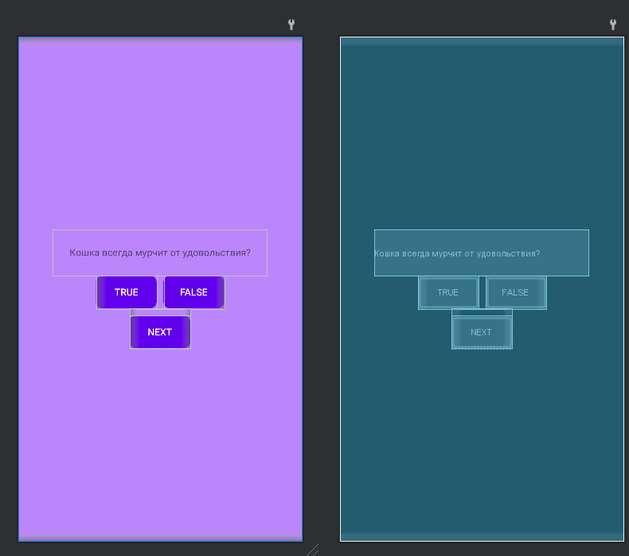

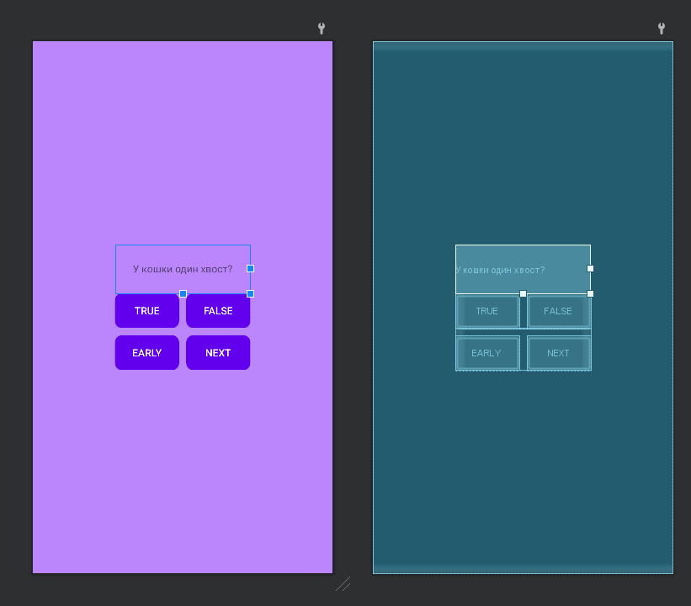

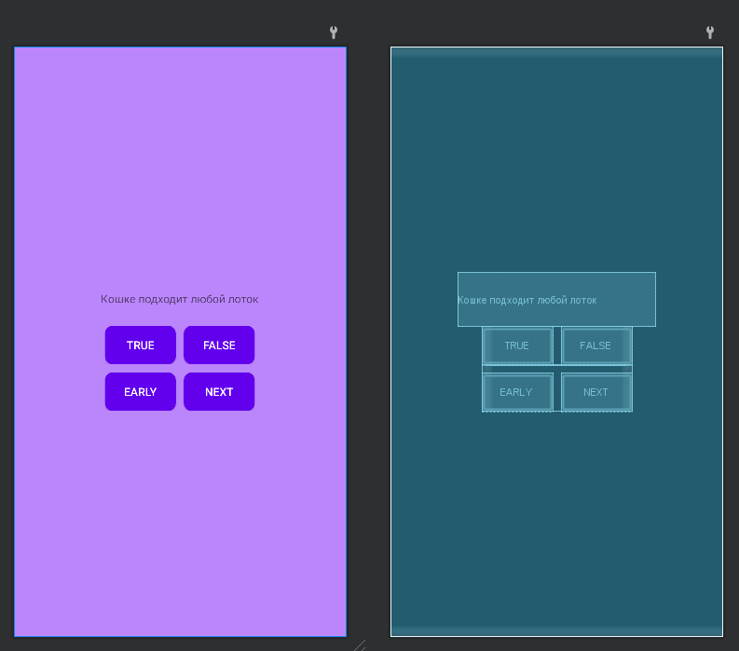

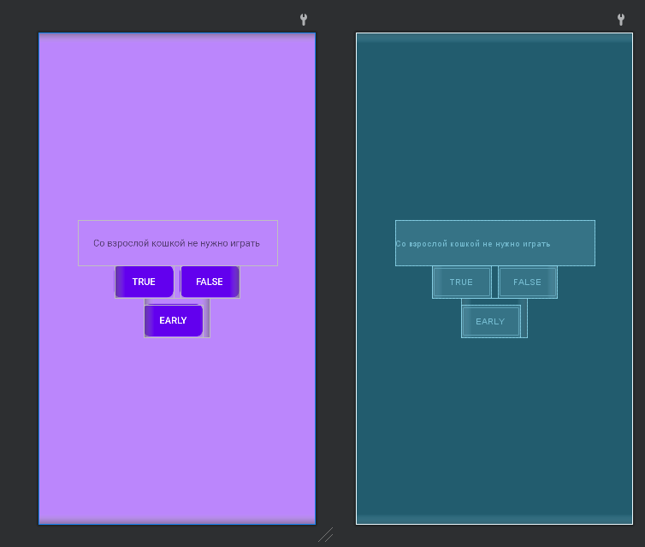

**Вывод**:

Я научилась работать с LinearLayout и лучше разбираться в андроид студио.